**SRI CHANDRASEKHARENDRA SARASWATHI VISWA MAHAVIDYALAYA**

**(UNIVERSITY ESTABLISHED under section 3 of UGC Act 1956)**

**ENATHUR,** **KANCHIPURAM – 631 561**



**PROBLEM SOLVING TECHNIQUES IN C LAB**

**LABORATORY RECORD**

**Name :** T. ROHITH

**Reg. No :** 112534041

**Class :** I YEAR BCA

**Subject :** SEC101 - PST IN C LAB

**SRI CHANDRASEKHARENDRA SARASWATHI**

**VISWA MAHAVIDYALAYA**

**(University Established under section 3 of UGC Act 1956)**



**BONAFIDE CERTIFICATE**

**This is to Certify that this is the bonafide record of work done by**

**Mr./~~Ms~~. T.ROHITH** **, with Reg. No 112534041 of I Year BCA in the Problem Solving Techniques in C Lab during the year 2025.**

**Staff-in-charge** **Head of the Department**

**Submitted for the Practical Examination held on ________________________**

**Internal Examiner** **External Examiner.**

**INDEX**

|  |  |  |  |  |
| --- | --- | --- | --- | --- |
| **S.No.** | **Date** | **Title** | **Page No.** | **Signature** |
| 1 | 24 Jul 2025 | CELSIUS TO FAHRENHEIT | 1 |  |
| 2 | 31 Jul 2025 | FIBONNACI SERIES | 3 |  |
| 3 | 07 Aug 2025 | SQUARE AND CUBE OF NUMBERS | 5 |  |
| 4 | 14 Aug 2025 | GENERATE ODD NUMBERS | 7 |  |
| 5 | 21 Aug 2025 | GENERATE GRADE | 9 |  |
| 6 | 28 Aug 2025 | GENERATE TOWER | 11 |  |
| 7 | 04 Sep 2025 | PALINDROME OR NOT | 14 |  |
| 8 | 25 Sep 2025 | STRING HANDLING | 17 |  |
| 9 | 25 Sep 2025 | ARRAY SORTING | 20 |  |
| 10 | 09 Oct 2025 | FACTORIAL | 23 |  |
| 11 | 09 Oct 2025 | SWAPPING OF NUMBER | 25 |  |
| 12 | 23 Oct 2025 | USING STRUCTURES | 27 |  |
| 13 | 23 Oct 2025 | FILE PROGRAMMING | 29 |  |

|  |  |  |
| --- | --- | --- |
| **1** | **CELSIUS TO FAHRENHEIT** | **DATE:**  **24 Jul 2025** |

**AIM :**

**Write a C program to Convert temperature from Celsius to Fahrenheit and vice versa.**

**ALGORITHM :**

**Step 1:** Start the program.

**Step 2:** Display the menu options:

* Option 1 → Convert Celsius to Fahrenheit
* Option 2 → Convert Fahrenheit to Celsius

**Step 3:** Read the user’s choice.

**Step 4: if** the choice = 1 goto step 5, else goto step 9

**Step 5:** Read the Celsius value.

**Step 6:** Convert celsius to Fahrenheit using the formula: Fahrenheit=(Celsius×9/5)+32

**Step 7:** display the converted Fahrenheit value.

**Step 8:** Goto step 15.

**Step 9: if** the choice is 2:goto step 11.Else goto step 14.

**Step 11:** Read the Fahrenheit value.

**Step 12:** Convert it to Celsius using the formula: Celsius=(Fahrenheit−32)×5/9.

**Step 13:,**Display the converted Celsius value.

**Step 14:** Display an error message: “Invalid choice! Please run the program again and choose 1 or 2.”

**Step 15:** End the program.

**FLOW CHART:**

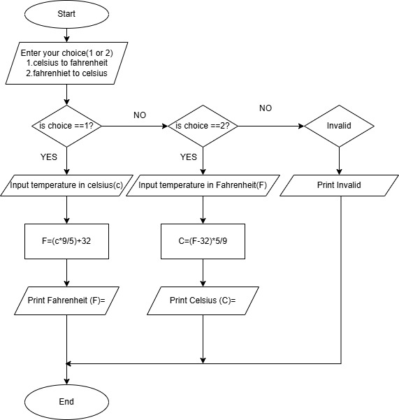

**SOURCE CODE :**

<https://github.com/murugamuruga123/clab/blob/main/CELSIUS%20TO%20FAHRENHEIT.c>

**OUTPUT:**

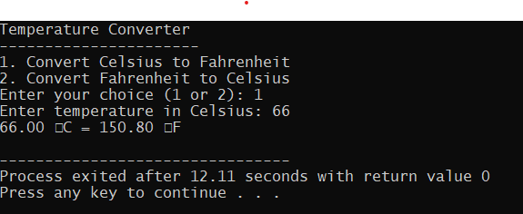

**RESULT :**

Thus the program is compiled and executed successfully with verified output.

|  |  |  |
| --- | --- | --- |
| **2** | **FIBONACCI SERIES** | **DATE:**  31 Jul 2025 |

**AIM :**

**Write a C program to generate a Fibonacci series.**

**ALGORITHM :**

**Step 1:** Start the program.

**Step 2:** Declare variables:  
  n (number of terms),  
  t1 = 0 (first term),  
  t2 = 1 (second term),  
  nextTerm (to store next Fibonacci number),  
  i (loop counter).

**Step 3:** read the number of terms,n.

**Step 4:** i=3

**Step 5**: Calculate nextTerm = t1 + t2.

**Step 6**: Print nextTerm.

**Step 7:** t1 = t2,

t2 = nextTerm.

I=i+1

**Step 8**: if i<n repeat step 5, else continue

**step 9:** End the program.

**FLOW CHART:**

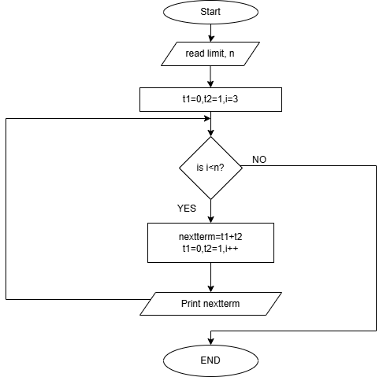

**SOURCE CODE:**

[**https://github.com/murugamuruga123/clab/blob/main/fibonnaci%20series.c**](https://github.com/murugamuruga123/clab/blob/main/fibonnaci%20series.c)

**OUTPUT:**

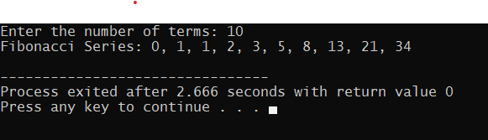

**RESULT :**

Thus the program is compiled and executed successfully with verified output.

|  |  |  |
| --- | --- | --- |
| **3** | **SQUARE AND CUBE OF NUMBERS** | **DATE:**  **07 Aug 2025** |

**AIM :**

Write a C program to calculate the square and cube of 1 to n numbers

**ALGORITHM :**

**Step 1:** Start

**Step 2:** Declare integer variables limit( n) and counter (i)

**Step 3:** Read the value n

**Step 4:** Use a **for loop** that runs from i = 1

**Step 5:** Calculate square = i * i

**Step 6:** Calculate cube = i * i * i

**Step 7:** Display i, square, and cube

**Step 8:** i = i + 1

**Step 9:** If i < n go to step 5 else goto step 10

**Step 10:** stop

**FLOWCHART:**

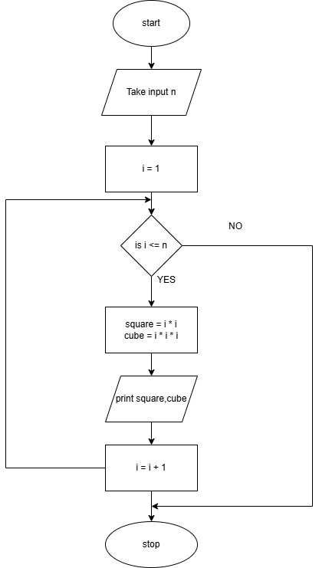

**SOURCE CODE :**

<https://github.com/Rohith-Tech-king/c-lab/blob/main/square%20and%20cube%20for%20numbers.c>

**OUTPUT:**

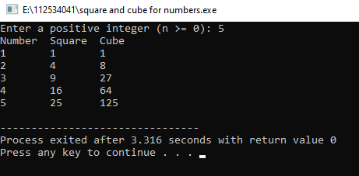

**RESULT :**

Thus the program is compiled and executed successfully with verified output.

|  |  |  |
| --- | --- | --- |
| **4** | **GENERATE ODD NUMBERS** | **DATE:**  **14 Aug 2025** |

**AIM :**

Write a C program to display odd numbers from 1 to n

**ALGORITHM :**

**Step 1:** Start

**Step 2:** Declare integer variables limit (n) and counter (i)

**Step 3:** Read the value of n

**Step 4:** Use a **for loop** that runs from i = 1

**Step 5:** if i % 2 != 0 (i.e., i is odd) goto step 6, else goto step 7

**Step 6:** Print i

**Step 7:** i=i+1

**Step 8:** Goto Step 5

**Step 9:** Stop

**FLOWCHART:**

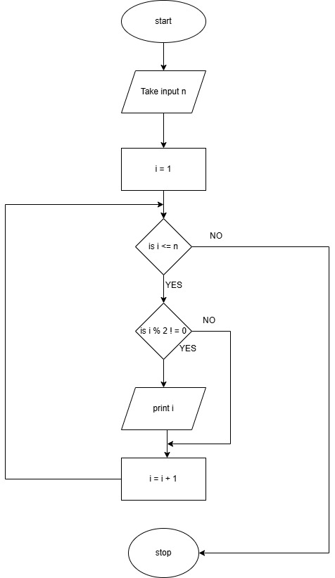

**SOURCE CODE:**

[**https://github.com/Rohith-Tech-king/c-lab/blob/main/odd%20num.c**](https://github.com/Rohith-Tech-king/c-lab/blob/main/odd%20num.c)

**OUTPUT:**

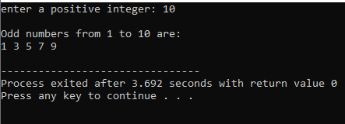

**RESULT :**

Thus the program is compiled and executed successfully with verified output**.**